Structure of JWT

A JWT consists of 3 parts -  


* Header
* Payload
* Signature

This is how a JWT token looks like-  
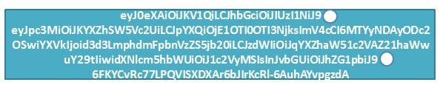  
The 3 parts of JWT are seperated by a dot.Also all the information in the 3 parts is in base64 encoded format.  
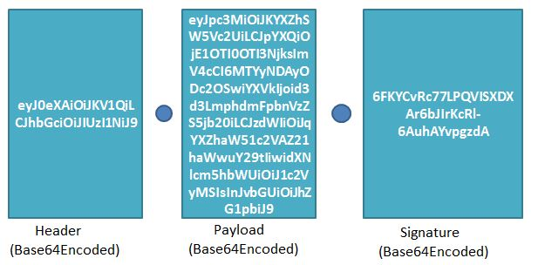  
Let us have a look at each of the three parts of JWT and its functionality.  
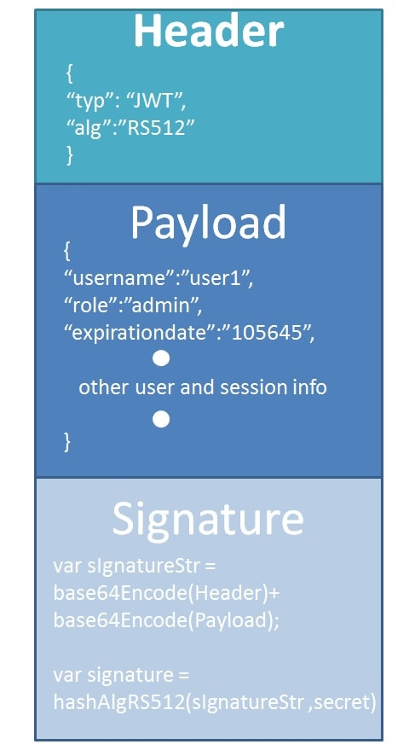

An important point to remember about JWT is that the information in the payload of the JWT is visible to everyone. There can be a "Man in the Middle" attack and the contents of the JWT can be changed. So we should not pass any sensitive information like passwords in the payload. We can encrypt the payload data if we want to make it more secure. However we can be sure that no one can tamper and change the payload information. If this is done the server will recognize it.

Creating a JWT Token

We will be creating a JWT token using [JWT Online Token Generator](https://www.javainuse.com/jwtgenerator)  
Specify the payload data as folows-  
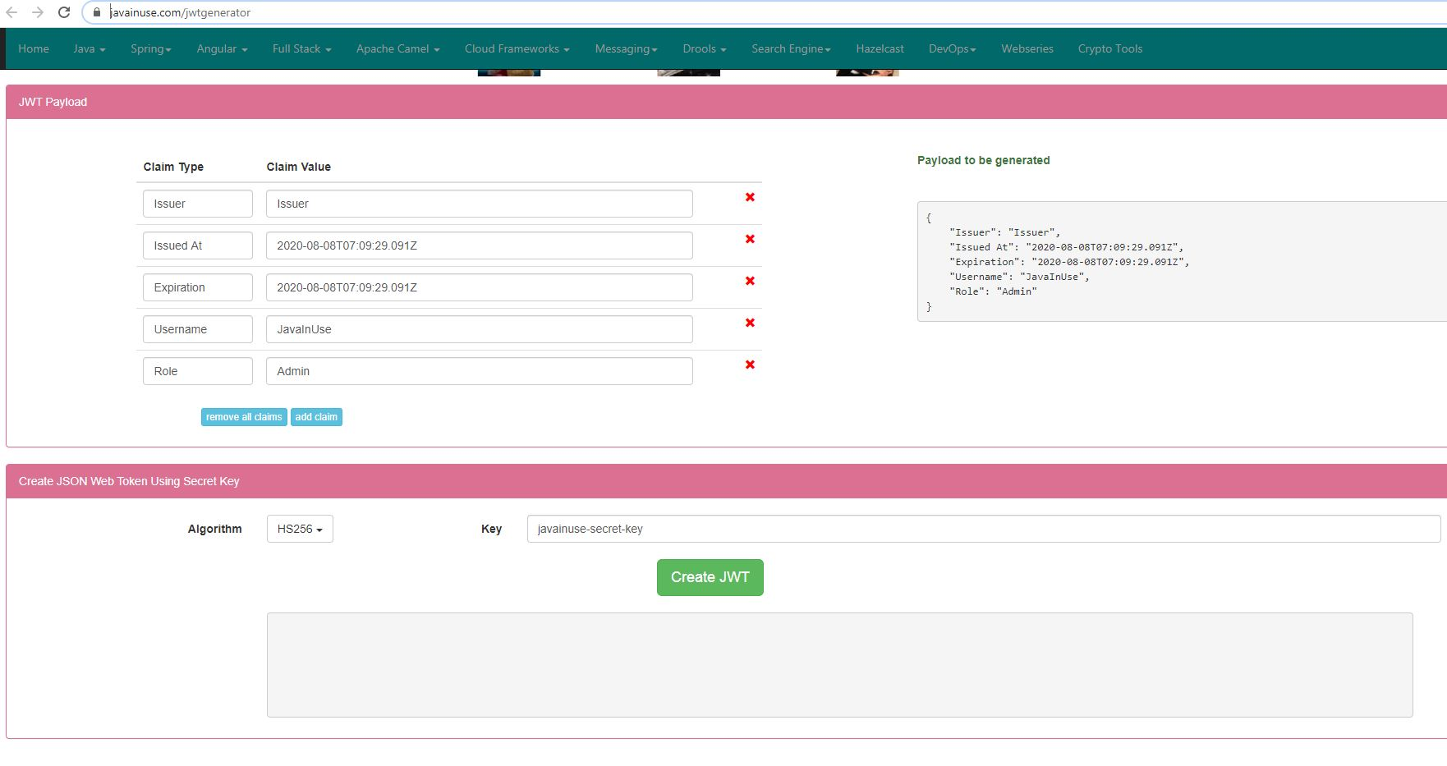

Inspect the contents of the created token

We will be inspecting JWT token using [JWT Online Decoder](https://www.javainuse.com/decodeJWT)  
  
